W1D3 – Quiz 1 (10 points)

1. (1 point) What is the difference between the Internet and the World-Wide Web (WWW)? Simply state briefly, how the two are related.

Internet incorporates the world wide web and other services e.g. email, online gaming, ftp, chatrooms

While the world wide web is a collection of websites and pages.

1. (2 points) Given an image file named, google-logo.png, write a piece of HTML code to create a hyperlink with this image, such that when it is clicked on the browser, it takes the user to the homepage of Google’s website (i.e. [www.google.com](http://www.google.com)).

<a href="[www.google.com](http://www.google.com))."><img src="/google-logo.png " alt=”google Link”></a>

1. (0.5 point) From the HTML code you have written in Question 2 above, is your reference (i.e. URL) for the image an absolute or relative URL?

relative

1. (0.5 point) From the HTML code you have written in Question 2 above, is your reference (i.e. URL) for the hyperlink element an absolute or relative URL?

absolute

1. (3 points) Write valid HTML code that would display the content shown below:

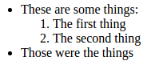

<ul>

<li><p>These are some things:</p>

<ol>

<li>The first things</li>

<li>The second thing</li>

</ol>

</li>

<li>Those were the things</li>

</ul>

1. (3 points) Write HTML code that will display the content shown below:

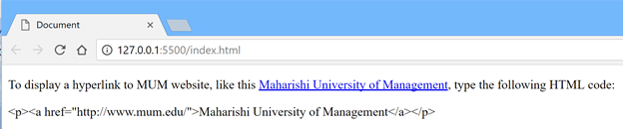

<html>

<head>

<title>Document</title>

</head>

<body>

<main>

<p>

To display a hyperlink to MUM website, like this <a href=” [http://www.mum.edu/”> Maharishi University of Management </a](http://www.mum.edu/\”> Maharishi University of Management </a)>, type the following HTML code:

</p>

&lt;p&gt;

&lt;a href=quot;http://www.mum.edu/&quot;&gt;Maharishi University of Management&gt;/a&gt;

&lt;p&gt;

</main>

</body>

</html>

1. (1 Bonus point) Write down 4 possible commands/methods (i.e. verbs) that an HTTP Request can use.
   1. Get
   2. PUT
   3. POST
   4. HEAD

//-- The End --//